Chapter 7, Solution 23.

Since the 2  resistor, 1/3 H inductor, and the (3+1)  resistor are in parallel, they always have the same voltage.

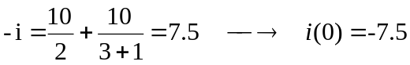
The Thevenin resistance 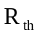 at the inductor’s terminals is
 